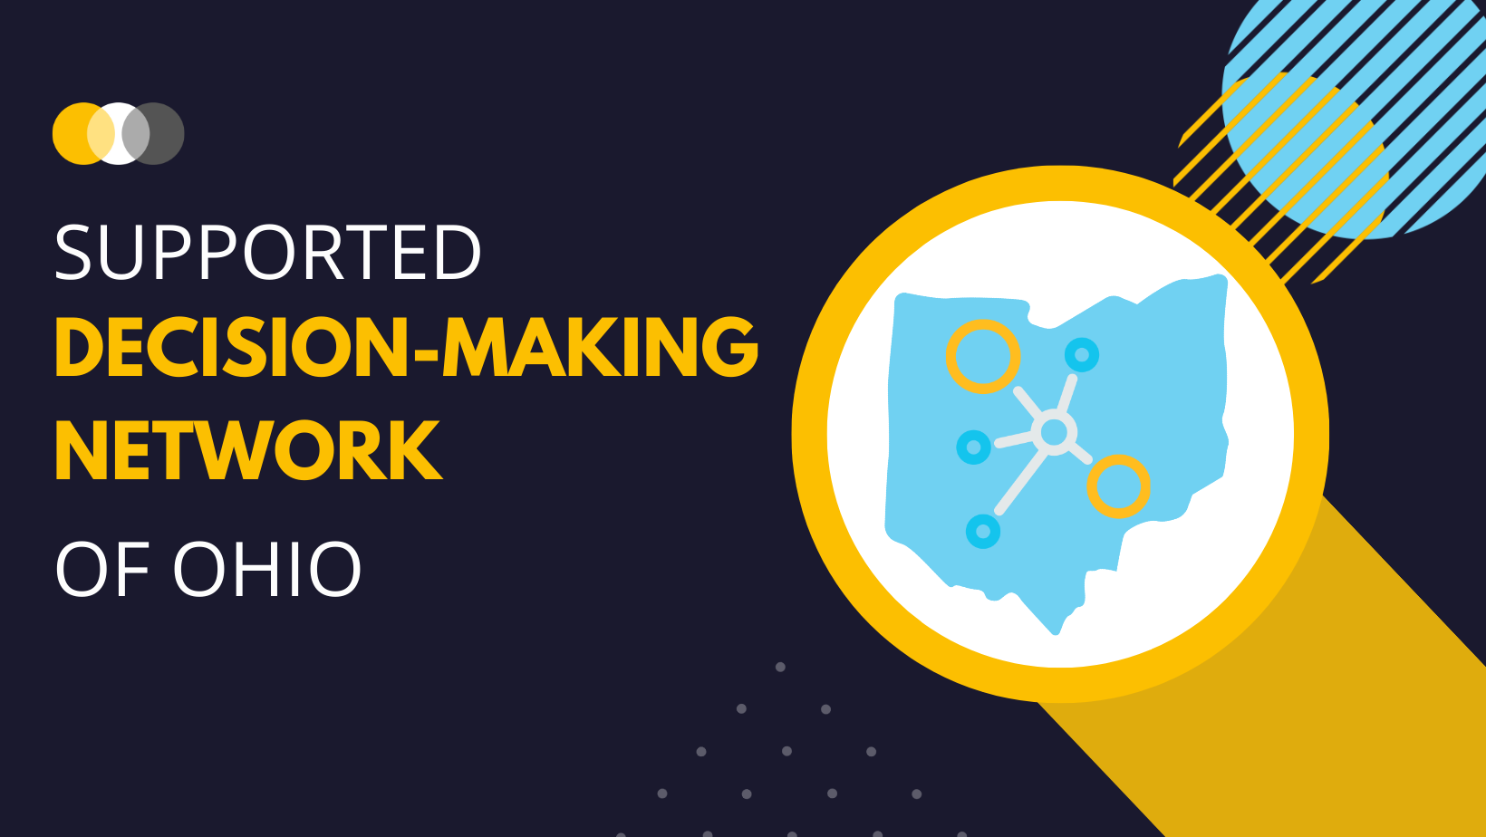
Strategic Plan Progress Report

Date:

FINANCIAL
Strategic Objective | Initiatives | Accomplishments
Get “adequate” funding! | Grants
 | Fundraising
 | Additional revenue-generating activities

Next Steps:

OUTREACH
Strategic Objective | Initiative | Actions Completed
Expand our reach & impact | Develop a marketing plan
 | Provide training
 | Offer CEUs

Next Steps:

INTERNAL
Strategic Objective | Initiative | Actions Completed
Develop capacity | Create bylaws/articles of incorporation
 | Become 501c3
 | Implement Strategic Plan

Next Steps:

LEARNING & GROWTH
Strategic Objective | Initiative | Actions Completed
Improve our knowledge of existing perspectives & practices around SDM/guardianship | Lean baseline for guardianships awarded across the state
 | Survey parents re: knowledge of SDM/guardianship

Next Steps:

CONCLUSIONS/RECOMMENDATIONS:

